1. Is there any difference in fares by different class of tickets?

Yes

Note – Show a boxplot displaying the distribution of fares by class

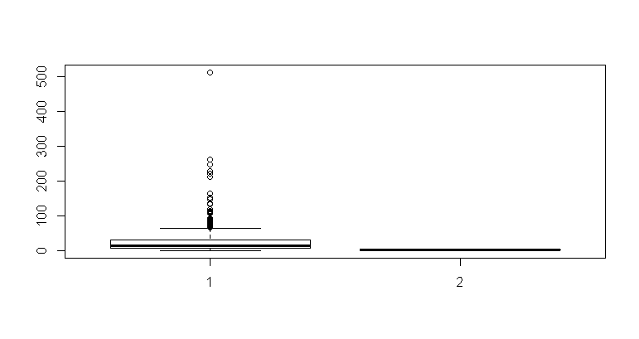

1. b. Is there any association with Passenger class and gender?

Note – Show a stacked bar chart